Child Safety Policy
for students

Purpose: To give students user-friendly advice about child safety.
Updated by 27 January 2021

important Principles of Student Safety

Everyone has a right to be safe.
- We all need to make sure our school is safe, supportive, inclusive and empowering.
- Normally, we should not share confidential matters with others. However, when someone’s physical or psychological safety is at risk, it is important to seek help from a trusted adult.
- All staff are responsible for students and must look out for their safety and wellbeing.
- The Principal ensures that staff understand their responsibility to keep kids safe.
- Marist-Sion staff work with parents to give students the best education possible and keep them safe.

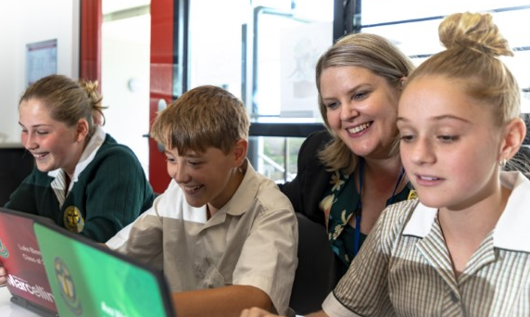
Student participation
All students need to help Marist-Sion College be
a safe place for all. Students are made aware how they can report abuse or concerns about safety by staff.

The Student Representative Council (SRC) has the important job of conveying students’ views about
how to keep students safe.
Comments to: srccaptains@mscw.vic.edu.au

Reporting and responding

If a student is concerned about safety for themselves or another student, they should talk to a trusted adult.

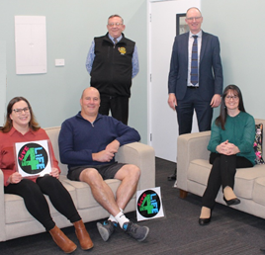
Staff Responsibilities
All staff are made aware of indicators of abuse, the need to be observant and their responsibility to respond to child safety issues.
They often discuss child protection and safety.

Help is always available AT THE COLLEGE
- Principal - Mr Houlahan;
- Child Protection Officers - Mrs Burgess (DP: Pastoral Care);
Mrs Hunt (DP: Learning);
Mr Woodhouse (Director: Catholic Identity & Mission);
- Your Tutor or your Head of House;
- Wellbeing Centre staff: Jo John, Mel Bradley, Ryan Peace, David Hobbs, Deacon Mark; wellbeing@mscw.vic.edu.au
- Teachers; or office staff.

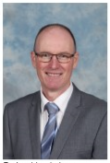  Peter Houlahan  Principal  principal@mscw.vic.edu.au | 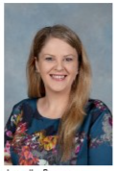  Janelle Burgess  DP: Pastoral Care  jburgess@mscw.vic.edu.au | 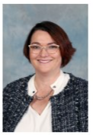  Narelle Hunt  DP: Learning  nhunt@mscw.vic.edu.au | 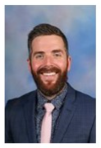  Peter Woodhouse  Director: Catholic Identity & Mission  pwoodhouse@mscw.vic.edu.au

Other help
- A trusted family member
- Police – dial 000 if urgent
- Your family doctor
- https://kidshelpline.com.au 1800 55 180
- Feeling Safe: Facts and Information for Secondary Students

